: Project Brief and Documentation

# What and Why

|  |  |  |
| --- | --- | --- |
| The project is in essence to make a logo, color scheme, style guide and a PWA. It is to be made for Zitrus UF and it would be used to display information and act as a contact page for the company.  How the PWA will be used is presumably by customers looking to buy the services that Zitrus UF are going to provide and eventually people following the progress of the company, like Family, UF workers or interested teachers. |  | PWA The best of both worlds ***“***At their heart, Progressive Web Apps are just web applications. Using progressive enhancement, new capabilities are enabled in modern browsers. Using service workers and a web app manifest, your web application becomes reliable and installable. If the new capabilities aren't available, users still get the core experience.***”***  *- www.web.dev* |

# Goals

The project is in essence to make a logo, color scheme, style guide and a PWA. It is to be made for Zitrus UF and it would be used to display information and act as a contact page for the company.

# Target Audience

## What devices is the target audience working with

How the PWA will be used is presumably by customers looking to buy the services that Zitrus UF are going to provide and eventually people following the progress of the company, like Family, UF workers or interested teachers

# Website Functionality and Content

## What content is important

The important content would be what they do, who they work with and what products and services they offer.

## Important Calls To action

For this website, the most important call to action would be to contact   
Zitrus UF as that is how they will be selling their services.

# Wireframes and Mockups and Logo Drafts

## Logo Design

### Inspiration and similar companies

With the basics laid down when it comes to what and why we are building the logo, style guide and PWA I began drafting logos and appropriate colors I took my main inspiration from companies like American megatrends, IBM, Zitrus Holding AB, Acqua Limone. I took inspiration from those companies because of the connection with IT and for Zitrus Holding AB, Acqua Limone the citrus theme was the main reason.

When the logo drafts later where discussed with Zitrus UF they decided that they wanted a logo more like Acqua Limone and less of an IBM or American Megatrends logo. After discussing with Zitrus UF the logo in Figure 2 was decided.



Figure 2, Final logo design

Figure 1, Logo design drafts

## Website Design

If we go back to the basics there is an abundance of company landing pages and some even have similar webapp functionality, but they differ hugely in style, functionality. When asked Zitrus UF provided a two sites that they liked the styling of, the first [w10.se](http://w10.se/) and the second was a bootstrap template.

After consulting with Zitrus UF the first mockups and wireframes where made figure 5 shows the mockups.

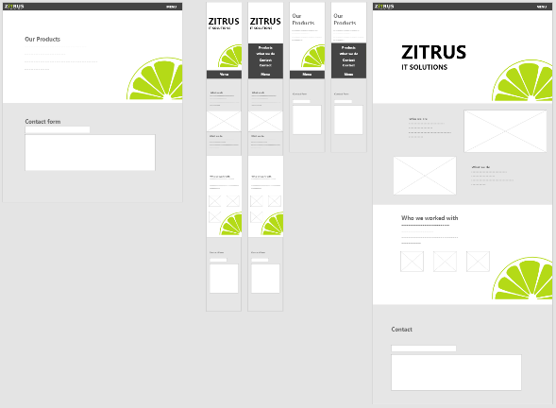



Figure 3, Bootstrap Template that Zitrus provided for inspiration

Figure 4, W10.SE, provided by Zitrus for inspiration

Figure 5, Mockups for the PWA



# Finished PWA

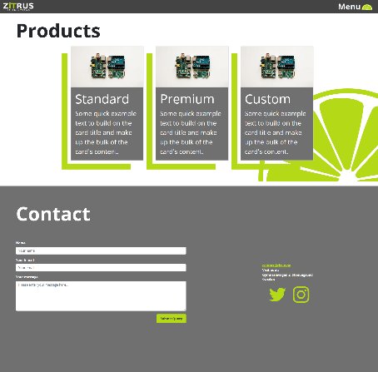

Figure 6, Finished PWA

Figure 7, Finished PWA

The finished PWA is shown in Figure 6 and 7,   
it consists of two main pages, a landing page and a   
Product page.

Most of the content is on the landing page.   
The product page consists of three cards and a   
duplicate of the contact section on the landing page.

The final product is relatively close to the mockup that   
was decided on with minor changes to the amount of   
content, specifically on the What we do section.

The PWA is installable, has an offline fallback page,   
is designed responsively to work with any device and  
any window size.



Figure 6, Finished PWA

# Testing of PWA

## Performance and speed

The first performance test was performed on [gtmetrix.com](https://gtmetrix.com/reports/klovaaxel.github.io/A6rsoEMX). After some optimizing the score landed on what figure 9 displays, the last steps to a more optimized page according to gtmetrix.com would be to utilize more caching functionality.

[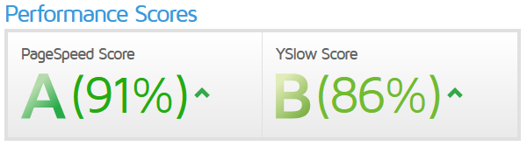](https://gtmetrix.com/reports/klovaaxel.github.io/A6rsoEMX#)

Figure 9, Performance score from gtmetrix.com

The second performance test was performed on [developers.google.com](https://developers.google.com/speed/pagespeed/insights/?url=https%3A%2F%2Fklovaaxel.github.io%2FZitrusWebAppDist%2F), The test resulted in a sore of 96, sown in figure 10, to get a higher score the website recommended moving from .png images to .webp or .jpeg but as many of the images are temporary and Zitrus UF probably will replace them not much effort was put into the optimization of those images.

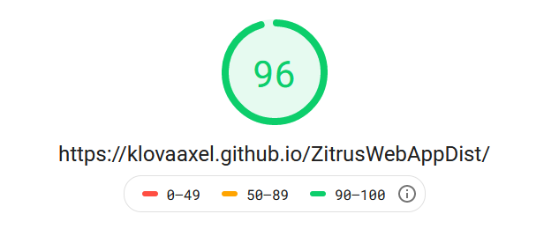

Figure 10, Performance score from developers.google.com

## W3C validation

The PWA was tested for w3c validation first by their [unicorn](https://validator.w3.org/unicorn/check?ucn_uri=https%3A%2F%2Fklovaaxel.github.io%2FZitrusWebAppDist%2F&ucn_task=conformance) validator, the validator produced one error, the error is related to a bootstrap function, the bootstrap code also produced some warnings.

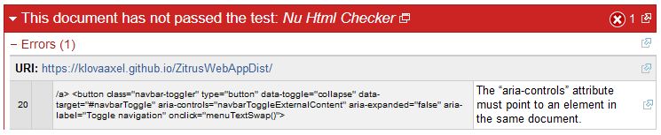

Figure 11, Unicorn validation

The PWA was also tested on the W3C [Jigsaw](https://jigsaw.w3.org/css-validator/validator?uri=https%3A%2F%2Fklovaaxel.github.io%2FZitrusWebAppDist%2F&profile=css3svg&usermedium=all&warning=1&vextwarning=&lang=en#css) validator and the results showed no errors in the CSS written specifically for the website but two errors in the bootstrap CSS.

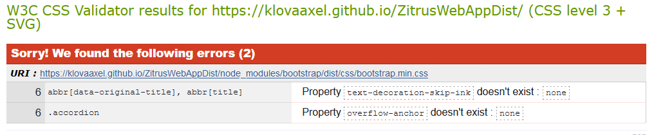

Figure 12, Jigsaw validation

The errors in the bootstrap code where not fixed as they are not critical and it is a imported library of code and if it where to be updated the errors would most likely come back and need the same fixes again.



## Accessibility Tests

The Accessibility of the website was first tested on [color.a11y.com](https://color.a11y.com/Contrast/) which resulted in a failed result, the result failed because of the main header of the page and its color for the iT part of the ZiTRUS name. The test failed it but on the website the lack of contrast has been compensated with a bolder and larger font style. The color #b4da17 is not normally used for text and I have therefore chosen to overlook this.

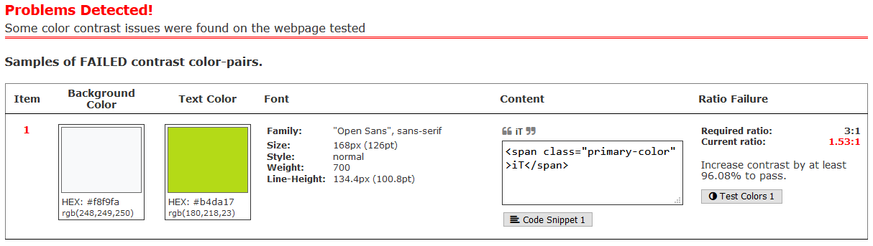

Figure 13, color.a11y.com validation

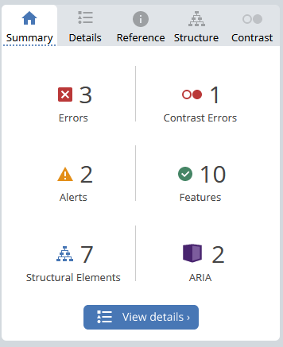

The second accessibility test was performed on [wave.webmain.org](https://wave.webaim.org/report#/https://klovaaxel.github.io/ZitrusWebAppDist/). This accessibility test was a bit more in-depth then the one at color.a11y.com in that it went through the colors, structure and readability of the PWA. The three errors the website produced are in the contact section and will be resolved when ZiTRUS provide links for the social media they intend to use. The contrast issue is the same as discussed in the color.a11y.com test and the alerts are that the contact form doesn’t have a legend as the h2 in that section serves as that as well as a heading for that section and the second warning is that the menu calls a JS event on click, but the menu works without it if for some reason it wouldn’t be called.

Figure 14, wave.webmain.org

Figure 14, wave.webmain.org usability test

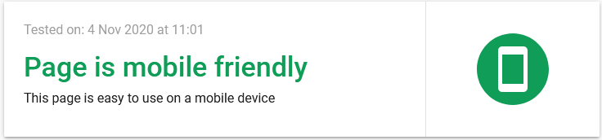The website has also been tested for mobile friendliness on [search.google.com](https://search.google.com/test/mobile-friendly?id=ADtgpG7W7AxBa4cyTIGYLg) where it got a passing score and no rendering issues, result shown in figure 15.

Figure 5, Search.google.com mobile friendly test